PRODUCT DESCRIPTION

Product Title

**B-Bay**

Product Scope

*The website helps organizations and individuals with products and goods meet customers and exchange and trade quickly and conveniently through auctions. The seller can sell his commodity and the buyer can buy the commodity at a price he can pay for the commodity.*

*-Provide information related to products and goods being auctioned, information about sellers providing products and goods, and other relevant news*

*-Record and store every bid paid in an auction;*

*-After the start of an auction, every time a website the highest price is recorded, and the person who bids that price can be viewed by all auction participants.*

Stakeholders

|  |  |  |
| --- | --- | --- |
| User Class | Expectation | Represented By |
| Gest | -Register or login an account.  -Be able to search the information of the product they want and read some introduce | Unauthorized Users |
| User | -Be able to search the information of the product they want and read some introduce  -Be able modify information account  -Be able to bid the product  -Be able to create and modify auction | Authorized User |
| Admin | -Manager auction -Manager account  -Manager automatic | Web Manager |

Functional Requirements

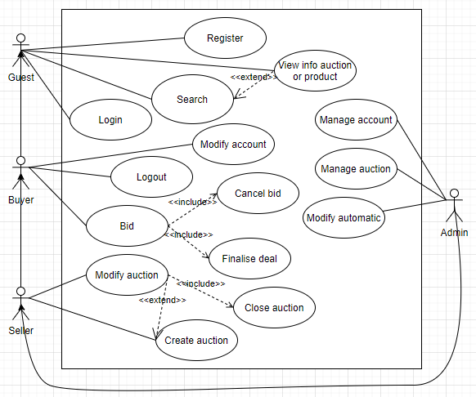

|  |  |  |
| --- | --- | --- |
| Requirement # | Description | Related Requirements |
| Login | Sign in to website |  |
| Register | Register account |  |
| Logout | Logout account |  |
| Create auction | Create and set up an auction |  |
| Close auction | Seller close auction |  |
| Bid | Bid product |  |
| Search product | Find the product and auction want |  |

Non-functional Requirements

*[Describes testable NF requirements]*

Targeted Platforms

Performance

-All data input and output screens are displayed for 5s.

-Server condition accommodating more than 1000 users.

Availabiliy

-The system ensures 24/7 operation.

-Edit and upgrade up to 1 time within 3 months.

-Dead time, hanging apps are not more than 2 hours in a year

Usability

-Tasks on the screen are processed as quickly as possible.

-The screen is easy to use in a few steps for one task.

Security

-User information is encrypted.

-Data is saved locally in the app.

Release Method

*[How product is delivered:*

* *One-shot (waterfall)*
* *Iterations/ incremental*
* *Agile/ Scrum*

*]*